Week 7 extra programs

/*1. Develop a Java program to create a class Student whose variables are usn, name and sem.

Derive a class Test from Student to include an array of cie marks of each course and their

corresponding credits in another array. Derive a class Exam from Test which includes an

array of see marks. Derive a class Result which calculates the grade for each course and the

SGPA. Create n student objects and displays all the above details.*/

import java.util.*;

import java.util.List;

class student

{

String usn,name;

int sem;

void input(String u,String n,int s)

{

usn=u;

name=n;

sem=s;

}

}

class test extends student

{

int cie[],credits[];

void get_cie(int n)

{

Scanner sc=new Scanner(System.in);

cie=new int[n];

credits=new int[n];

for(int i=0;i<n;i++)

{

System.out.println("enter cie marks with credits");

cie[i]=sc.nextInt();

credits[i]=sc.nextInt();

}

}

}

class exam extends test

{

int see[];

void get_see(int n)

{

Scanner sc=new Scanner(System.in);

see=new int[n];

for(int i=0;i<n;i++)

{

System.out.println("enter see marks");

see[i]=sc.nextInt();

}

}

}

class result extends exam

{

float sgpa;

void cal(int n)

{

int sum=0,cred=0;

int c;

int tot;

for(int i=0;i<n;i++)

{

tot=cie[i]+see[i]/2;

if(tot>=90)

c=10;

else if(tot>=80)

c=9;

else if(tot>=70)

c=8;

else if(tot>=60)

c=7;

else if(tot>=50)

c=6;

else if(tot>=40)

c=4;

else

c=0;

sum=sum+c*credits[i];

cred=cred+credits[i];

}

sgpa=(float)sum/(float)cred;

}

void display()

{

System.out.printf("%22s %22s %22d %22f \n",usn,name,sem,sgpa);

}

}

class sgpa_students

{

public static void main(String args[])

{

Scanner sc=new Scanner(System.in);

System.out.println("enter no of students");

int n=sc.nextInt();

//student []st=new student[n];

//test []t=new test[n];

//exam []ex=new exam[n];

result []res=new result[n];

String u,nam;

int s;

for(int i=0;i<n;i++)

{

System.out.println(" -----enter details of student "+(i+1)+"-----");

System.out.println("enter usn and name ");

u=sc.next();

nam=sc.nextLine();

System.out.println("enter sem ");

s=sc.nextInt();

System.out.println("enter no of courses");

int nn=sc.nextInt();

res[i]=new result();

res[i].input(u,nam,s);

res[i].get_cie(nn);

res[i].get_see(nn);

res[i].cal(nn);

}

System.out.println("\t\t\t-----student details-----");

System.out.printf("%22s %22s %22s %22s \n","usn","name","sem","sgpa");

for(int i=0;i<n;i++)

res[i].display();

}

}

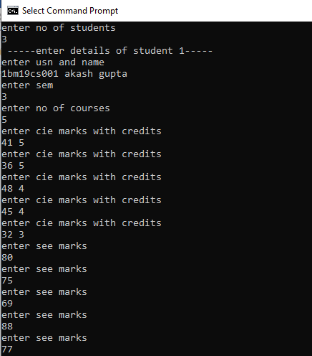

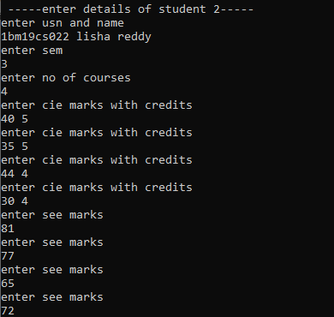

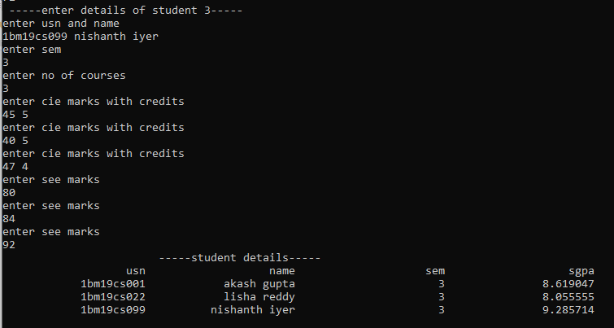

/*2. Develop a Java program to create a class PLAYER with member variables name,

matches_played and average. This class has an abstract method cal_average(String,int,int).

Derive two classes BATSMAN and BOWLER from PLAYER. Class BATSMAN has a

member variable runs_scored. Class BOWLER has a member variable runs_given. Create m

BATSMAN objects and n BOWLER objects. Calculate and display the average runs scored

by each BATSMAN and average runs given by each BOWLER.*/

import java.util.*;

import java.util.List;

class PLAYER

{

String name;

int matches_played;

float average;

void cal_average(String nam,int matches,int runs)

{

name=nam;

matches_played=matches;

average=(float)runs/(float)matches_played;

}

}

class BATSMAN extends PLAYER

{

int runs_scored;

void batsman()

{

Scanner sc=new Scanner(System.in);

System.out.println("enter total runs scored by batsman");

runs_scored=sc.nextInt();

}

void display1()

{

System.out.printf("%22s %22d %22d %22f \n",name,matches_played,runs_scored,average);

}

}

class BOWLER extends PLAYER

{

int runs_given;

void bowler()

{

Scanner sc=new Scanner(System.in);

System.out.println("enter total runs given by bowler");

runs_given=sc.nextInt();

}

void display2()

{

System.out.printf("%22s %22d %22d %22f \n",name,matches_played,runs_given,average);

}

}

class general

{

public static void main(String args[])

{

Scanner sc=new Scanner(System.in);

String nam;

int matches;

System.out.println("enter no of batsman");

int m=sc.nextInt();

BATSMAN []bm=new BATSMAN[m];

System.out.println("enter no of bowlers");

int n=sc.nextInt();

BOWLER []bl=new BOWLER[n];

for(int i=0;i<m;i++)

{

bm[i]=new BATSMAN();

System.out.println("----enter details of batsman "+(i+1)+"----");

bm[i].batsman();

System.out.println("enter name of batsman and matches-played ");

nam=sc.next();

matches=sc.nextInt();

bm[i].cal_average(nam,matches,bm[i].runs_scored);

}

for(int i=0;i<n;i++)

{

bl[i]=new BOWLER();

System.out.println("----enter details of bowler "+(i+1)+"----");

bl[i].bowler();

System.out.println("enter name of bowler and matches-played ");

nam=sc.next();

matches=sc.nextInt();

bl[i].cal_average(nam,matches,bl[i].runs_given);

}

System.out.println("\t\t\t-----batsman details-----");

System.out.printf("%22s %22s %22s %22s\n","name","matches-played","runs scored","average");

for(int i=0;i<m;i++)

bm[i].display1();

System.out.println("\t\t\t-----bowler details-----");

System.out.printf("%22s %22s %22s %22s\n","name","matches-played","runs given","average");

for(int i=0;i<n;i++)

bl[i].display2();

}

}

